ASSESSMENT - 12 | PYTHON - 05

*“PYTHON FUNCTION, LAMBDA FUNCTIONS, MODULES ”*



Submitted By

VAIBHAV PATIDAR

IPS ACADEMY, INDORE (M.P.)

**Date :** 16-12-2023

**Week 2** | **Day - 06**

**→ FUNCTION WITH RETURN KEYWORD :**

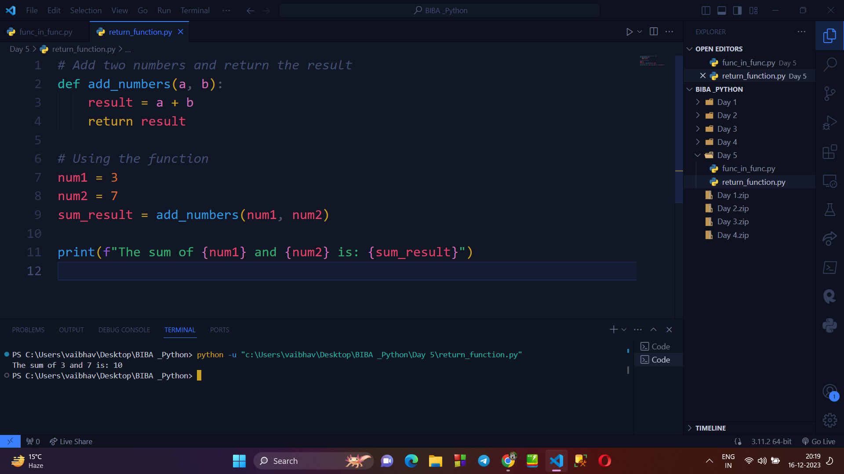

**→ NESTED FUNCTION IN PYTHON**

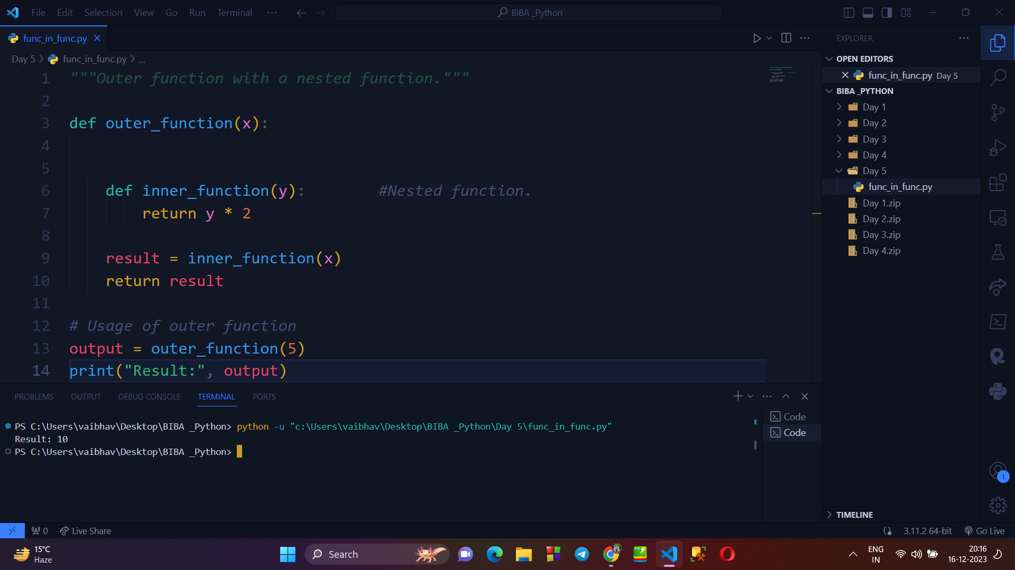

**→ PASS BY REFERENCE :**

* in Python every variable name is a reference. When we pass a variable to a function, a new reference to the object is created.

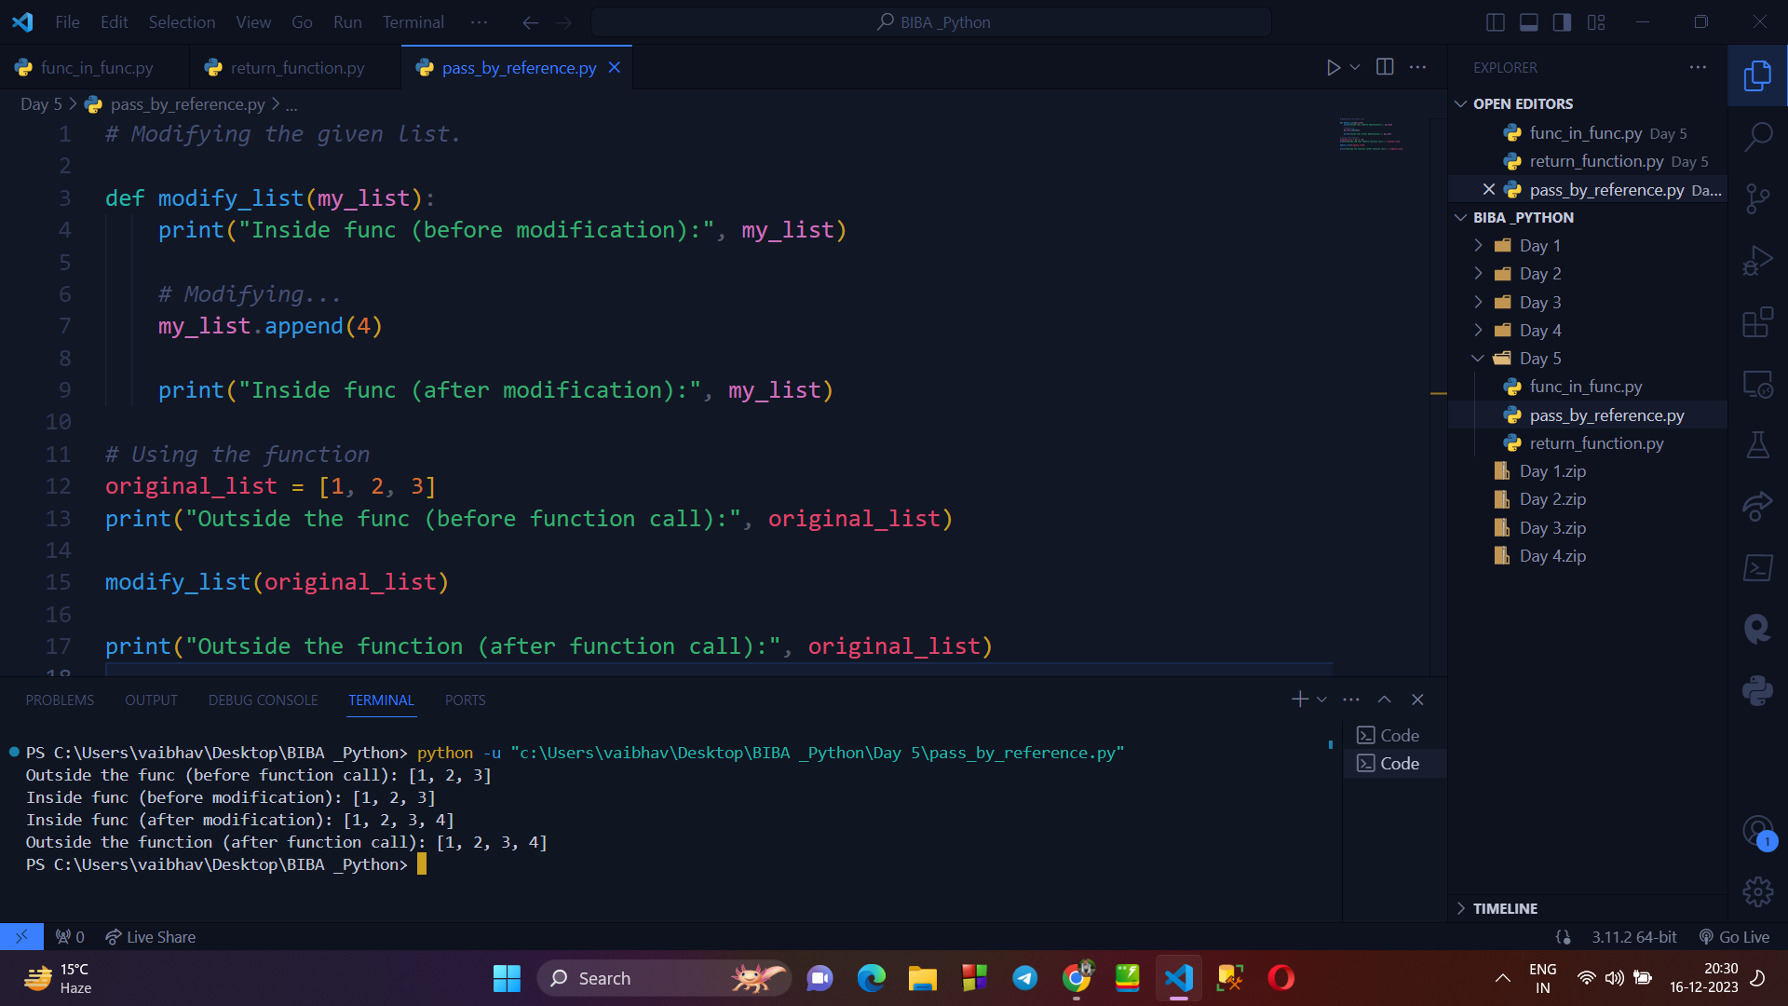

→ **PASS BY VALUE :**

* The values of the arguments are passed to functions.

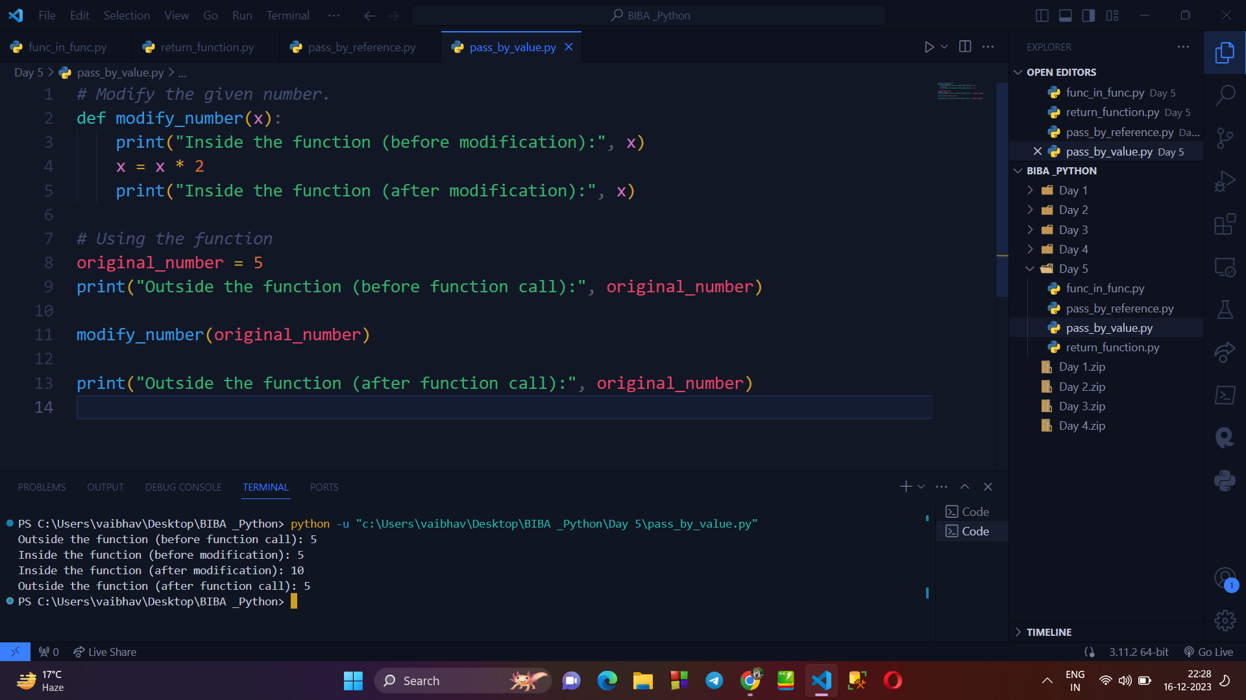

**→ MAP() METHOD IN PYTHON :**

* Returns a list of the results after applying the given function to each item of a given iterable (list, tuple etc.)

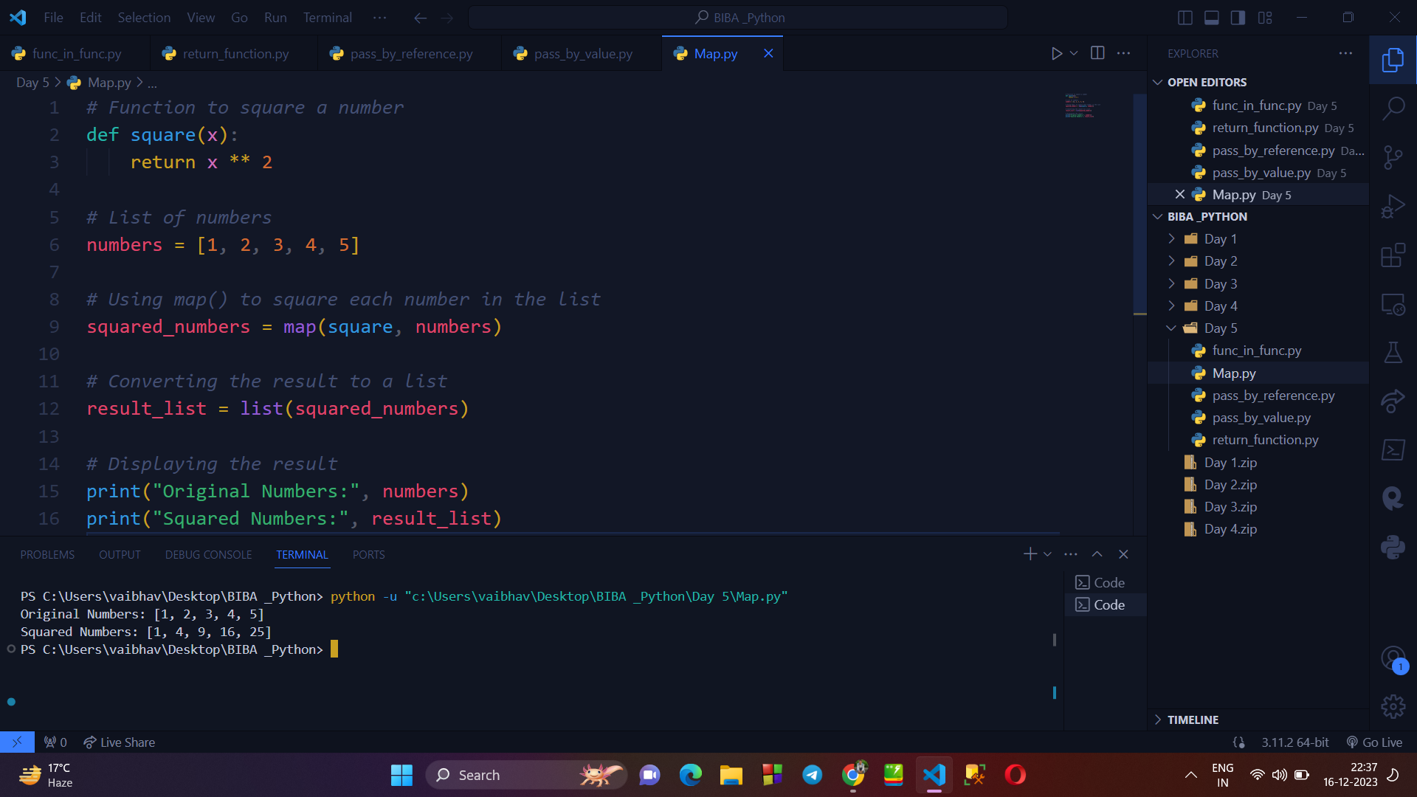

**→ MAP() METHOD WITH IF CASE :**

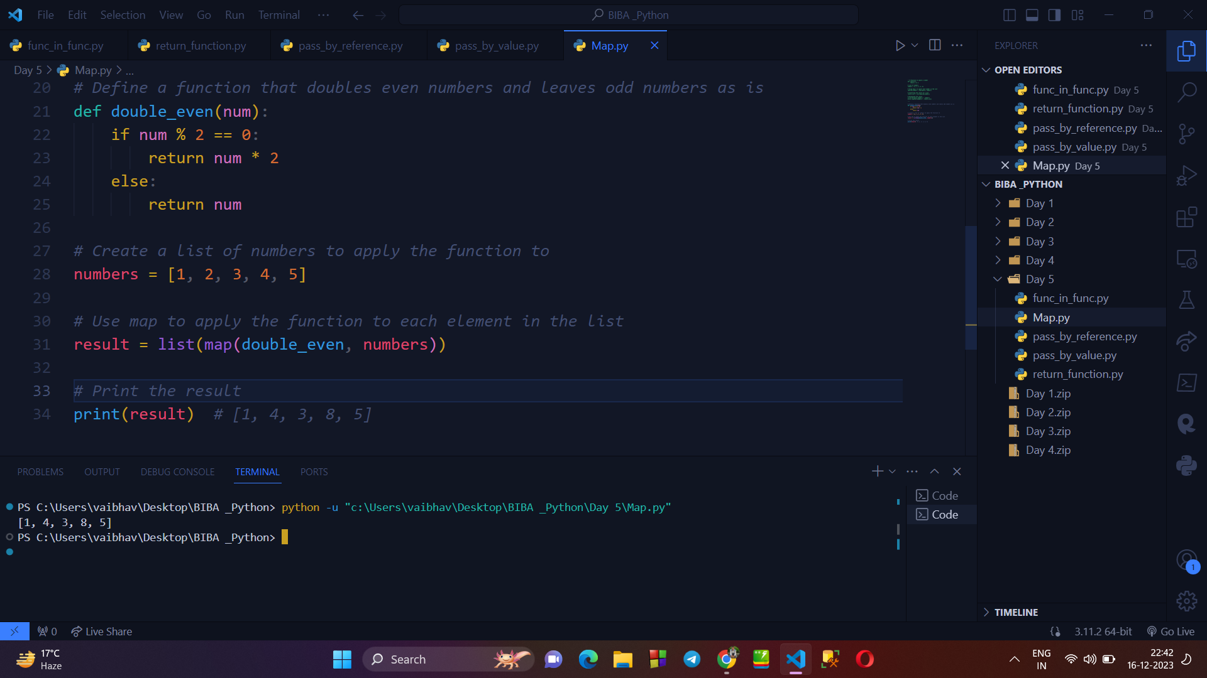

**STRING FUNCTIONS :** There are usually 7 string functions -

1. CAPITALIZE()
2. COUNT()
3. FIND()
4. LOWER()
5. UPPER()
6. REPLACE()
7. JOIN()

**Writing a program to explain all 7 STRING FUNCTIONS :**

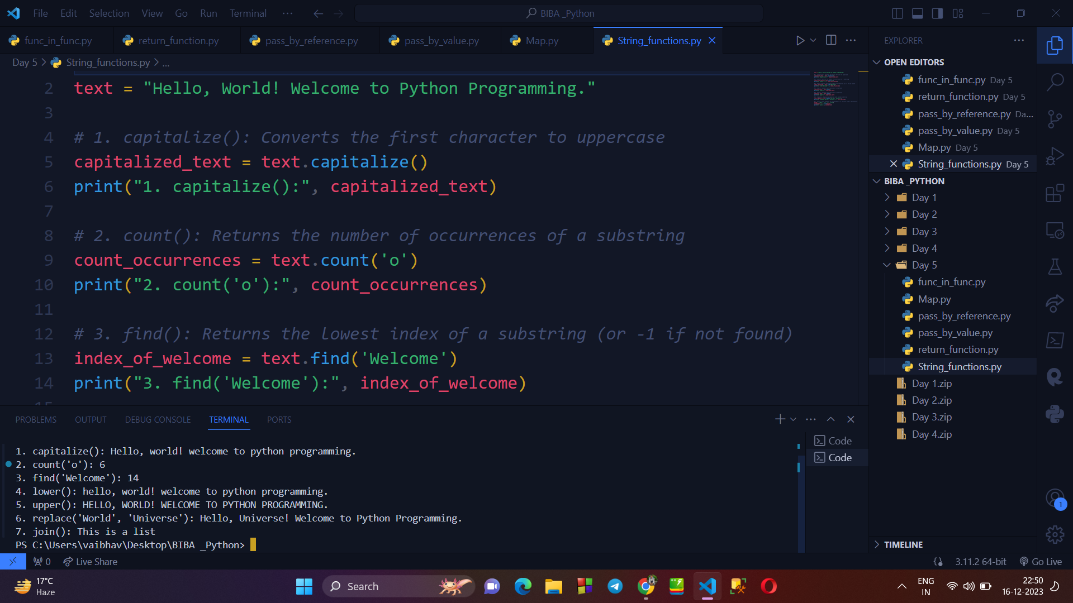

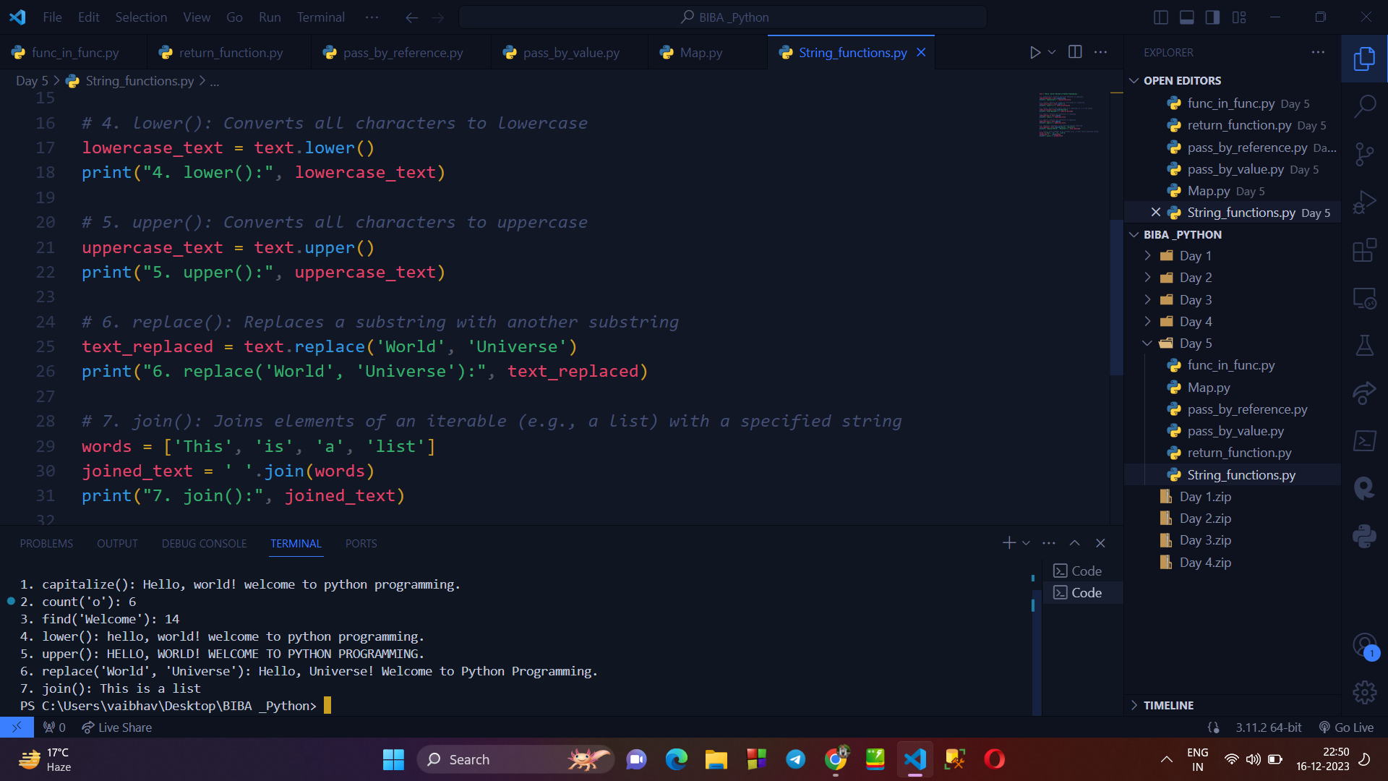

**→ LAMBDA FUNCTION WITH MAP() METHOD :**

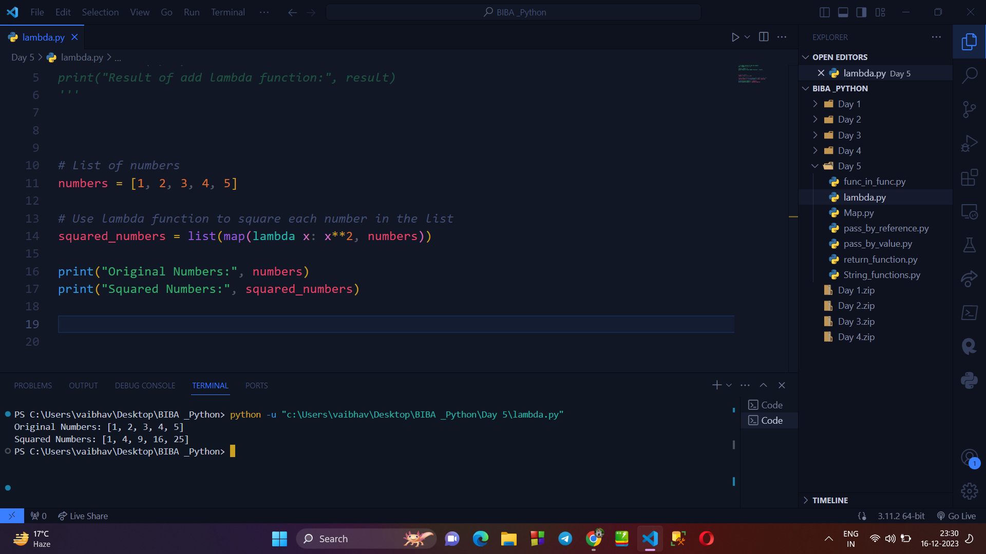

**→ LAMBDA FUNCTION WITH FILTER() METHOD :**

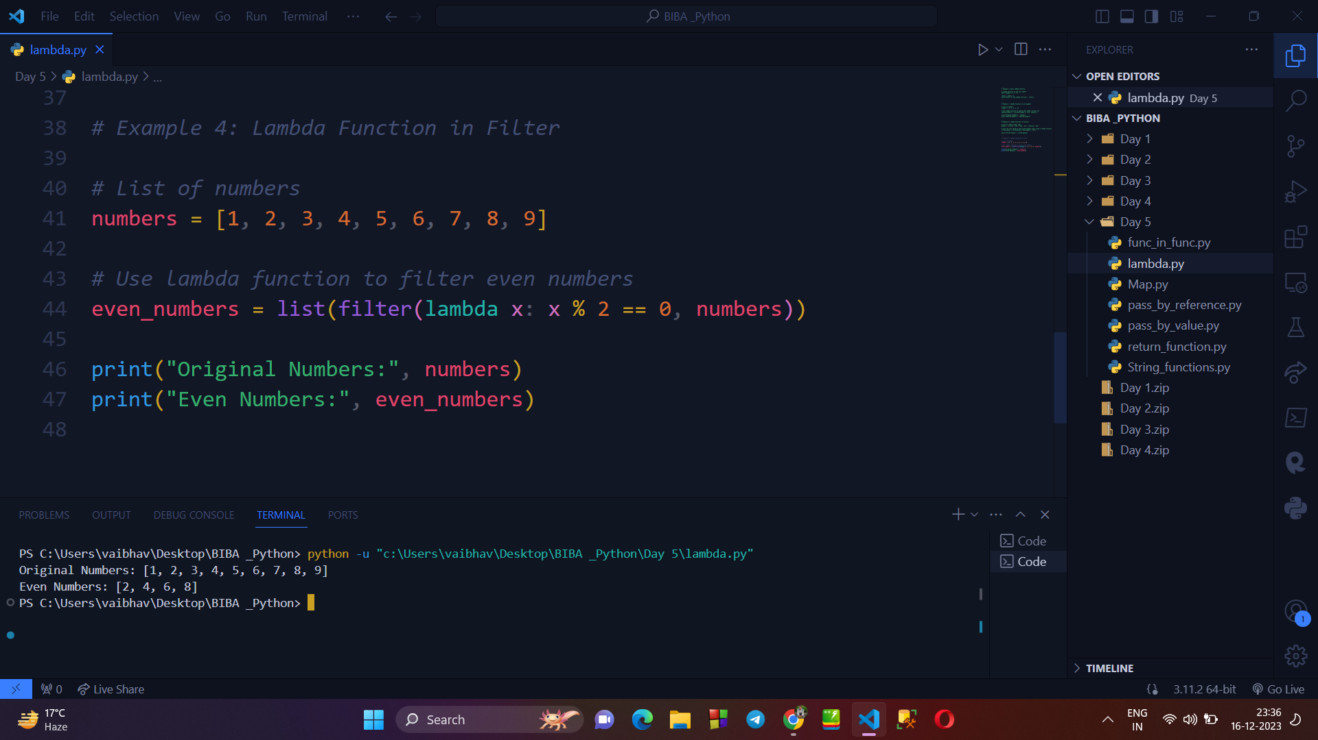

**→ DATETIME, TIME & CALENDAR MODULE IN PYTHON :**

1. **Writing program to display current date & time, time , etc.**

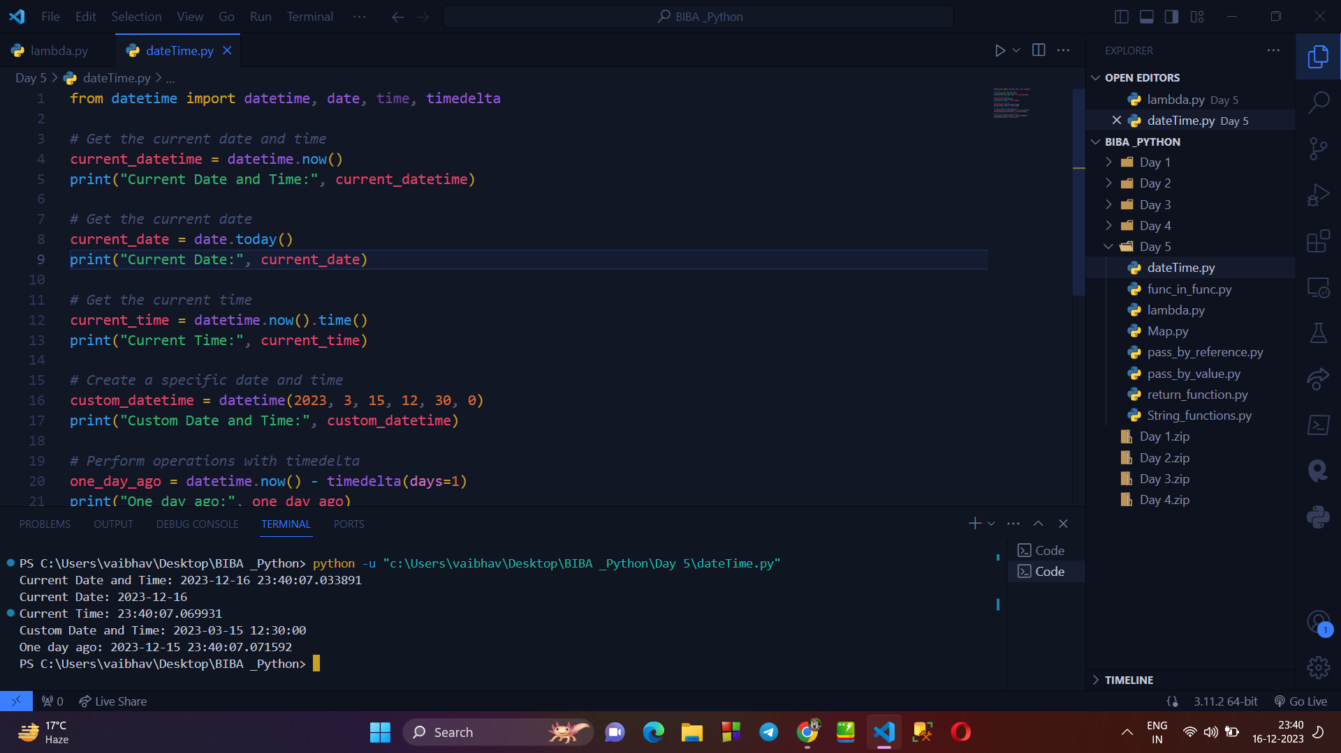

1. **Program using time module :**

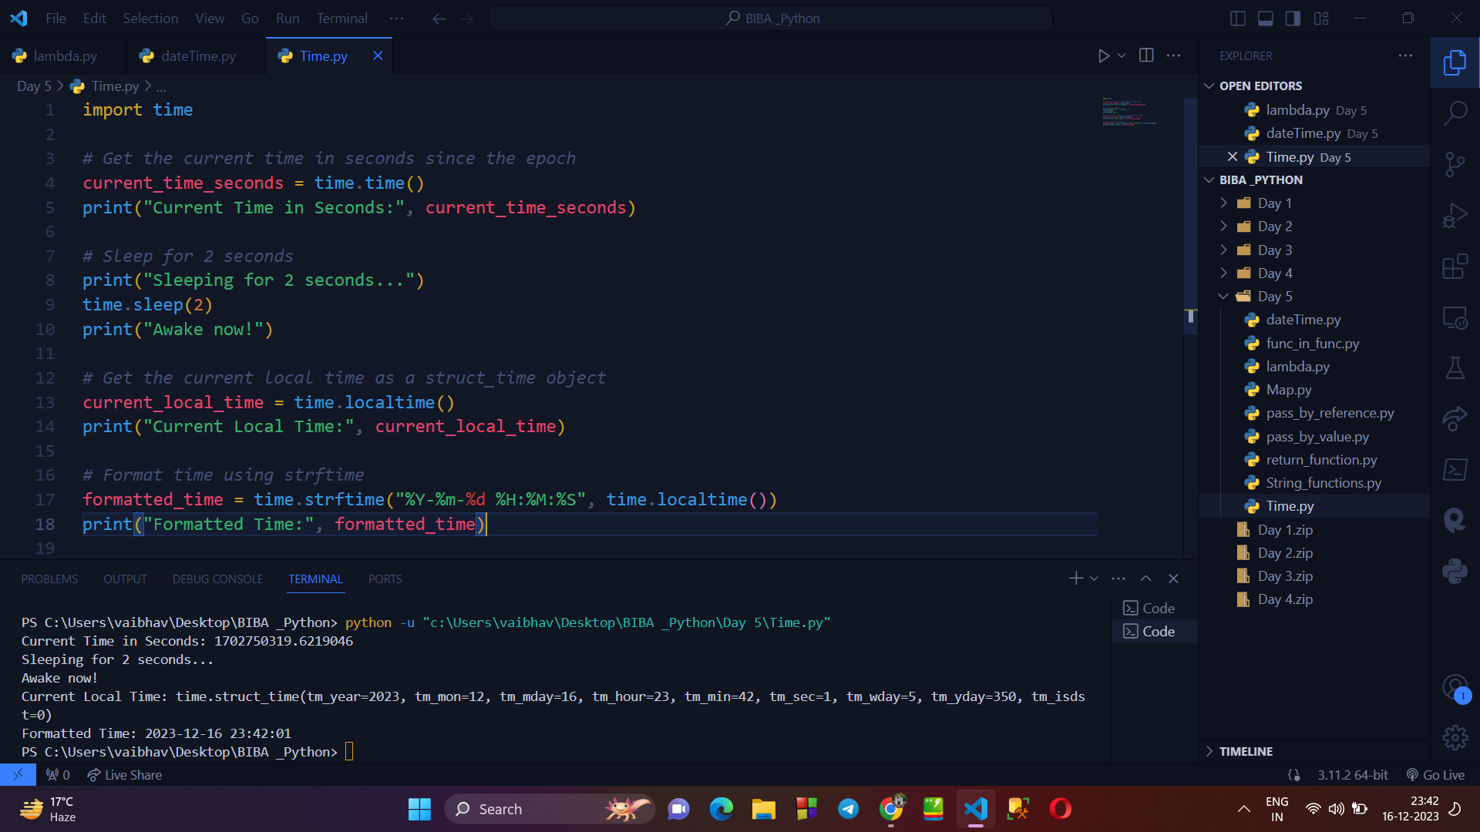

1. **Programs based on Calendar Module :**

